Media Release 22 July 2019

ACUSTICO LIGHTING WINS 2019 GOLD GOOD DESIGN AWARD
FOR DESIGNER ACOUSTIC LIGHTING COLLECTION
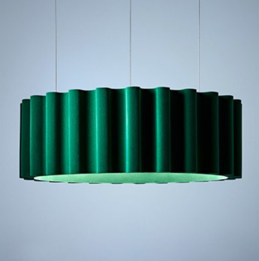 | 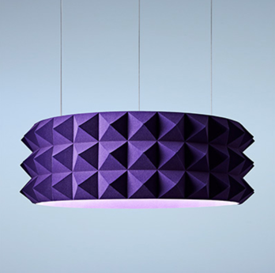 | 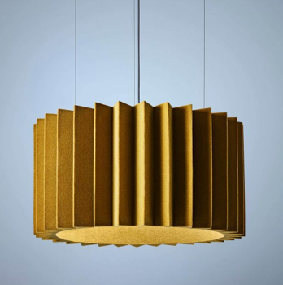
The Acustico Lighting team is thrilled to have recently won a 2019 Gold Good Design Award for its designer acoustic lighting.

Australia’s annual Good Design Awards program is one of the oldest and most prestigious international design awards in the world, promoting excellence in design. The Good Design Award Gold accolade is awarded to products, services or projects that have not only met the criteria for Good Design, but exceed them.

Following two years of research and development and with a commitment to human centred design, the Acustico Lighting Musica Collection promises triple impact with a sophisticated, elegant design and unprecedented acoustic and lighting solution.

Acustico Lighting commissioned independent research and sound level testing that showed Acustico Lighting’s ‘Musica’ Collection absorbs up to 30 per cent of conversational and 45 per cent of high frequency sound. The unique test results are reported in detail via the Acustico Sound Lab.

Architects and interior designers appreciate the dual utility and bold aesthetics of the Collection which creates a sophisticated and functional design feature. This explains why Acustico Lights are fast being installed in collaborative places, cafes and restaurants, education and public and aged living spaces across Australia.

The Collection features pendant and wall lights titled ‘Opera, Punk, Jazz and Jazzier’ which can be custom made to any size or colour, or specifiers can choose from the recommended twelve colour palette. Each light is made from GECA certified materials.
CEO of Good Design Australia, Dr Brandon Gien, said “Receiving a Good Design Award at this level is a significant achievement given the very high calibre of entries received this year.”
The Good Design Awards Jury praised the Acustico entry commenting: “Distinctive, fun and light weight, the Musica Collection features a well thought out appropriation of material and dual-functionality to absorb and diffuse sound. It is great to see the functionality showcased in a playful way that is incorporated into the light rather than as separate elements.
Incorporating feature pendants in a workspace ensures the functional acoustic aspect is where it is needed - at voice level.”
In 2017, Interior Designer, Samantha McKenzie, was in search of a beautiful light with acoustic impact for a client’s board room and she couldn’t find the solution she was seeking. So, she embarked on a journey to create her own, and from there Acustico Lighting was born.

As the Director of Acustico Lighting, Samantha McKenzie is committed to Australian-made, acoustic lighting design and has created a sophisticated five-part process that promises a Collection with a luxe velvety finish.

“Acoustics is widely recognised as a dark art. After countless prototypes, designs and learnings to create a light that makes spaces look, sound and feel better, the Good Design Award combined with encouraging user feedback is wonderful validation of the design,” said Samantha McKenzie.

“We recently installed our lights at RMIT University and it’s rewarding to know that students appreciate the beauty of the lights, while also recognising the space feels calmer because it’s less noisy.

“This Award marks just the beginning as we have more exciting designs underway using a unique production process with dedicated Melbourne craftspeople.”

Acustico Lighting is also a proud recipient of the prestigious 2018 International LIT Award for Pendant Lighting Award.

About Acustico Lighting

The Acustico Lighting Collection makes shared spaces look, sound and feel better.

Architects and designers value Acustico Lighting’s design aesthetic combined with the benefit of making a collaborative space less noisy and feel calmer. Independent testing reveals the Musica Collection absorbs up to 30 per cent of conversational and 45 per cent of high frequency.

The Acustico Lighting range is made by dedicated craftspeople in Australia and given the unique materials and manufacturing process, the ‘Musica’ Collection is available in any customised colour.

https://www.acusticolighting.com.au/

For further information

Sanna Conquest | Conquest Ink PR | sanna@conquestink.com.au | +61 425 808 889

Photography

Available upon request.

